**State Chart Diagrams:**

**Overview:**

The name of the diagram itself clarifies the purpose of the diagram and other details. It describes different states of a component in a system. The states are specific to a component/object of a system.

A State chart diagram describes a state machine. Now to clarify it state machine can be defined as a machine which defines different states of an object and these states are controlled by external or internal events.

Activity diagram explained in next chapter is a special kind of a State chart diagram. As State chart diagram defines states it is used to model lifetime of an object.

**Purpose:**

State chart diagram is one of the five UML diagrams used to model dynamic nature of a system. They define different states of an object during its lifetime. And these states are changed by events. So State chart diagrams are useful to model reactive systems. Reactive systems can be defined as a system that responds to external or internal events.

State chart diagram describes the flow of control from one state to another state. States are defined as a condition in which an object exists and it changes when some event is triggered. So the most important purpose of State chart diagram is to model life time of an object from creation to termination.

State chart diagrams are also used for forward and reverse engineering of a system. But the main purpose is to model reactive system.

Following are the main purposes of using State chart diagrams:

* To model dynamic aspect of a system.
* To model life time of a reactive system.
* To describe different states of an object during its life time.
* Define a state machine to model states of an object.

**State Chart Diagrams:**

State chart for Login Form:

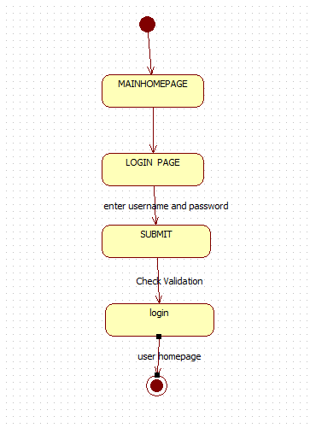

State chart for Register Form:

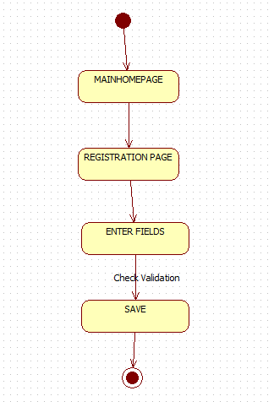

USER STATECHAT DIAGRAM

